This is a development tool to generate ncurses form code. First read the last page of this document for Other technical information you should know. Now you can use the development tool.
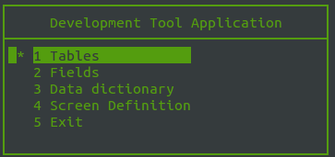

First define a table
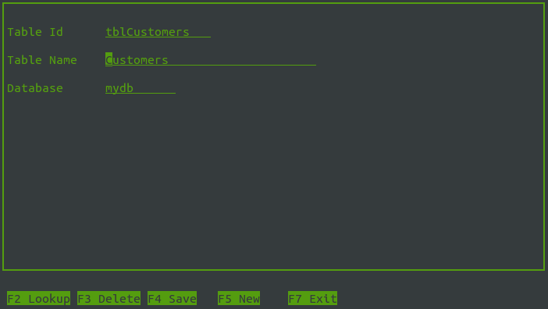

Next you define the fields

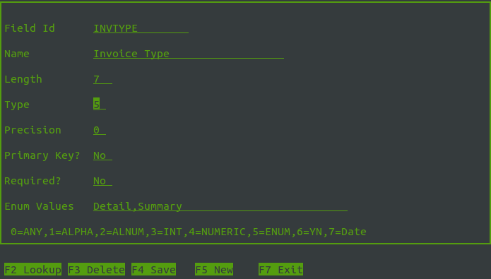
Then specify the fields that are in a table using the data dictionary
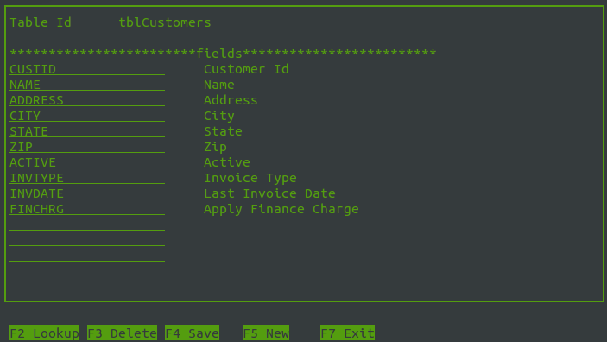
At this point the data dictionary is used when designing the screen. Unfortunately, this tool doesn’t generate sql scripts to create tables.

Here is how you can design a screen
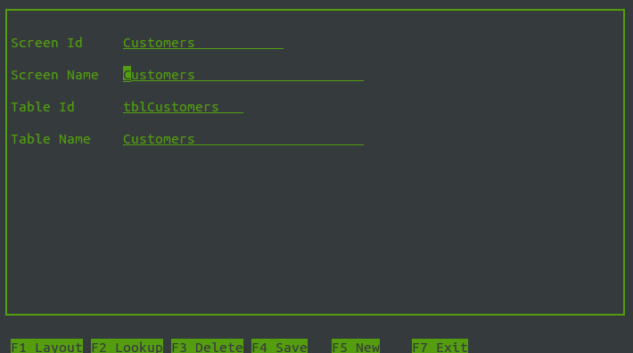

After you specify the screen id,screen name, the table the screen is based upon, you can press F1 to create the layout. 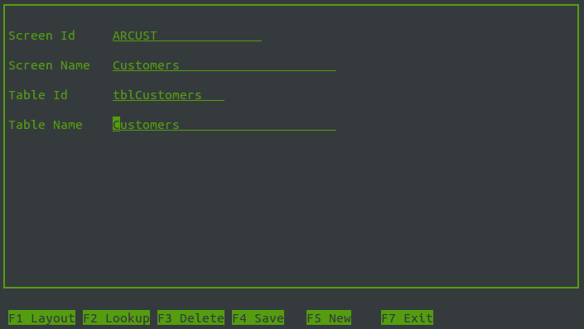

If you have not defined a screen yet, the screen is a blank canvas. You must design the screen.
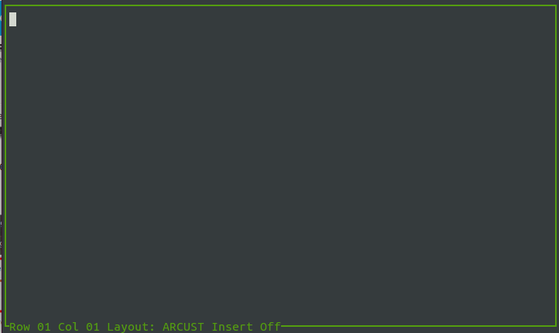
To start with, type a field label and a few spaces.
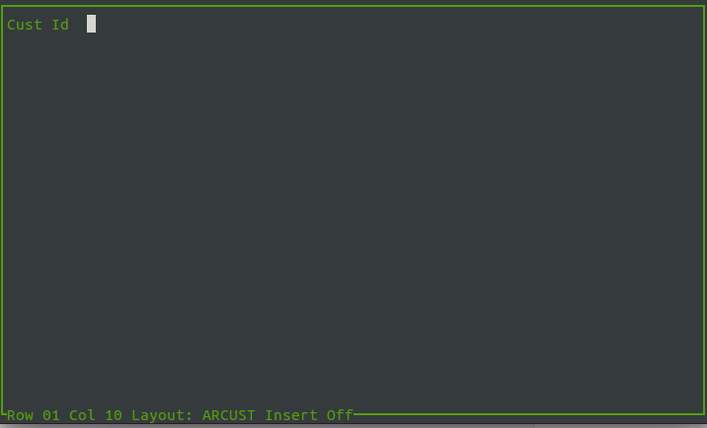

Press F1 to specify the field that will be used
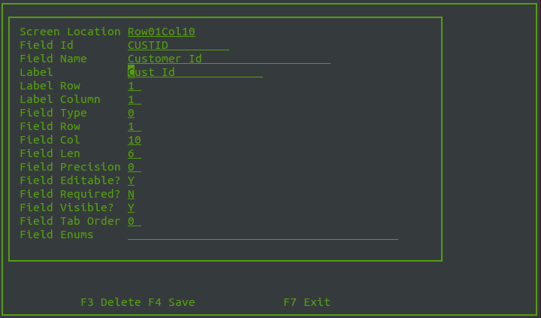
The field row, field column, label row, label column and label text is defaulted. You have to enter the field id (or use the F2 lookup) to get the field info from the fields you defined earlier. Press F4 to save this.
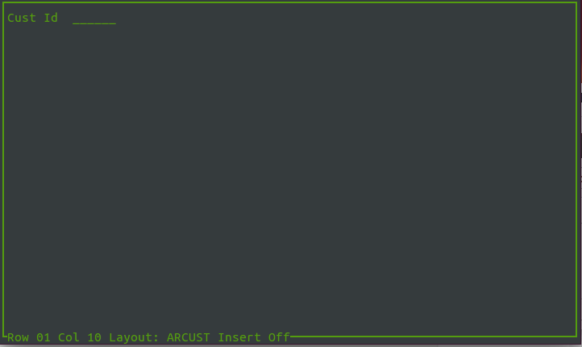

The field input area is shown with a line. This area is locked. When you move the cursor it will not go in this area.
Continue adding more labels and field in the manner described above.

If use F2 to specify static text not associated with a field.
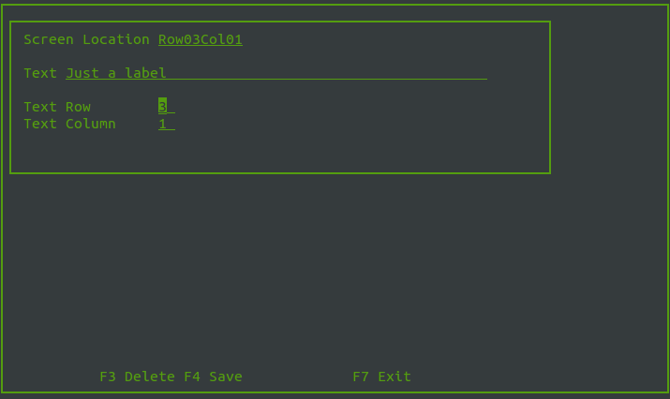
After saving
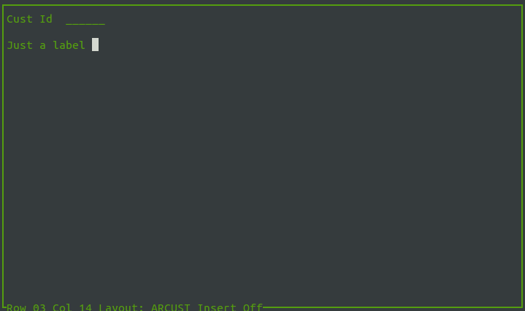
Here is the sample screen I’ve provided
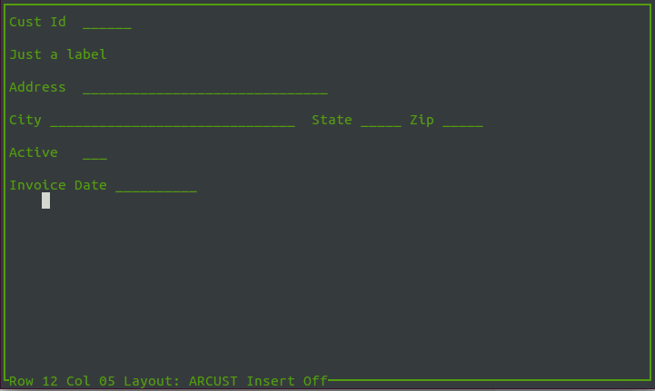

A few things to note:
The insert feature does not work yet.
You can use the tab key to move 5 spaces at a time.
To edit an existing field place the cursor on the first position of the field and press F1.
To edit a state text, place the cursor on the first position of the label and press F2.
Labels that where typed when defining a field can be changed on the canvas or in the edit fields. Static text cannot be changed on the canvas.

After you have defined some fields and text, it can be tricky to move the cursor around the canvas because some positions are locked. You just have to move the cursor with the arrow keys to get around the locked areas.
Once the canvas is completed you press F8 to generate the code. That code is written to a file with the name of the screen in the generate sub directory of development tool directory. After the file is generated it can be complied in the generate sub directory using the command “makeit”. You will see several warnings but there shouldn’t be errors, Once complied, execute the complied program and you should see the screen you designed and you can press tab, enter or down arrow to move around the fields.
The “makeit” script only works for the example provide. You need to edit it or create your own for screens you design.
So this is just a starting point that saves you the tedious parts of defining an ncurses screen in C code. You can edit this code to provide other functionality. A default function key template is provided but you need to provide the code. You can use the code of the development tool for ideas.

Here is the screen in design mode for the sample provided.

Other technical information you should know
Extract the zip file provide into a directory of your choice. Type “makeit” to build the development tool executable. You will see lots of warnings but hopefully no errors.

This application was written in C/C++ on Ubuntu 14.04.1
gcc --version
gcc (Ubuntu 4.8.2-19ubuntu1) 4.8.2

This application requires the following

NCURSES forms and menus library see
http://invisible-island.net/ncurses/ncurses-intro.html or
http://www.gnu.org/software/ncurses/
You can install this with this command

sudo apt-get install ncurses5-dev

SQLITE
http://www.sqlite.org
sqlite may already be installed in your build of ubuntu.
type sqlite3 at the shell prompt and if this appears then it is preloaded

SQLite version 3.8.2 2013-12-06 14:53:30
Enter ".help" for instructions
Enter SQL statements terminated with a ";"
sqlite>

But if it is not preloaded, you can install it with this command
sudo apt-get install sqlite3 libsqlite3-dev

The development tool database devTool.db is in this package

